
(PROJECT PROPSAL)

AUTOMATED RECOGNITION & ATTENDANCE SYSTEM

RASCHASATE PRALOMRAM
SUPHAWIT INNANCHAI
SUWICHAK MORA

SCHOOL OF APPLIED DIGITAL TECHNOLOGY
IN INFORMATION TECHNOLOGY

MAE FAH LUANG UNIVERSITY
2026

© COPYRIGHT BY MAE FAH LUANG UNIVERSITY

AUTOMATED RECOGNITION & ATTENDANCE SYSTEM

RASCHASATE PRALOMRAM
SUPHAWIT INNANCHAI
SUWICHAK MORA

A SENIOR PROJECT SUBMITTED TO
MAE FAH LUANG UNIVERSITY IN PARTIAL FULFILLMENT OF
THE REQUIREMENTS FOR THE DEGREE OF
SCHOOL OF APPLIED DIGITAL TECHNOLOGY
IN INFORMATION TECHNOLOGY

MAE FAH LUANG UNIVERSITY
2026
© COPYRIGHT BY MAE FAH LUANG UNIVERSITY

AUTOMATED RECOGNITION & ATTENDANCE SYSTEM

RASCHASATE PRALOMRAM
SUPHAWIT INNANCHAI
SUWICHAK MORA

THIS SENIOR PROJECT HAS BEEN APPROVED
TO BE A PARTIAL FULFILLMENT OF THE REQUIREMENTS
FOR THE DEGREE OF SCHOOL OF APPLIED DIGITAL TECHNOLOGY
IN INFORMATION TECHNOLOGY
2026
EXAMINING COMMITTEE
.......................................................................................................ADVISOR
(Asst.Prof. Mahamah Sebakor)
.......................................................................................................COMMITTEE
(Asst.Prof. Khwunta Kirimasthong)
.......................................................................................................COMMITTEE
(Asst.Prof. Surapol Vorapatratorn)

© COPYRIGHT BY MAE FAH LUANG UNIVERSITY
ACKNOWLEDGEMENT
The authors would like to express sincere gratitude to the project advisor and committee members for their valuable guidance, suggestions, and support throughout the development of this project. We would also like to thank our friends and classmates for their cooperation and encouragement. Finally, special thanks are given to our families for their continuous support.
ABSTRACT
This project proposes the development of A.R.A.S. (AUTOMATED RECOGNITION & Attendance System), an automated attendance system using face RECOGNITION technology. The system captures student images through a camera installed in the classroom, identifies students by comparing facial features with a stored database, and automatically records attendance based on the class schedule. The proposed system aims to reduce time consumption, minimize human error, and prevent attendance fraud compared with traditional manual attendance methods. The results of this project are expected to demonstrate that AUTOMATED RECOGNITION can significantly improve efficiency and accuracy in attendance management.
Keywords: Face Recognition, Automated Attendance, Computer Vision, Image Processing, Vue.js, Node.js, PyTorch, PDPA Compliance, Internationalization (i18n)

CONTENTS
ACKNOWLEDGEMENT 4
ABSTRACT 4
Project Overview 7
Objectives and Scope of the System 7
Objectives 7

Scope of Work 7
System Architecture 8-9
High-Level System Flow 9
System Architecture and Data Flow Description 10
Core System Components 11

Frontend Modules 11
Backend Services 11

CCTV AI Engine 11

Security and Access Control (IAM) 11

Key Functional Areas 12

Registration and Data Management 12

AI-Based Attendance 13

CCTV Monitoring and Tracking 14

Permission Management and Security Review 14

Installation and Deployment 15

Prerequisites 15

Required Network Ports 15

Start-Up Commands 15

Production Deployment 16

Control Documents and Development Process 16
Key Documentation 16
Development Directives 16

Summary and Recommendations 16

Key Recommendations for Next Steps 17

Conclusion 17

1. Project Overview
The AUTOMATED RECOGNITION and Attendance System is an integrated platform designed for student registration management, facial-Recognition-based attendance tracking, and CCTV-assisted environmental monitoring. It operates in conjunction with an Identity and Access Management (IAM) framework to rigorously regulate access control and manage user roles across the entire system.
- Project Name: AUTOMATED RECOGNITION and Attendance System
- Primary Objective: To support and automate attendance processes, thereby improving the efficiency and accuracy of student registration and attendance administration.
- Baseline Document Status: Source-Aligned Baseline
- Source Reference Date: August 21, 2026

2. Objectives and Scope of the System

2.1 Objectives
The system is engineered to support the following core functions:
- Manage student registration and maintain related data records.
- Facilitate web-based attendance processes utilizing advanced facial recognition technology.
- Integrate real-time CCTV data with AI-based facial detection capabilities.
- Govern user roles, permissions, and access through a centralized IAM framework.
- Support seamless configuration, monitoring, and deployment activities across various environments.

2.2 Scope of Work
The system encompasses the following functional areas:
- Account Management: Administration of general users and administrative accounts.
- Data Management: Handling of student profiles and historical attendance records.
- System Integration: Connecting CCTV hardware with AI-based recognition services.
- Security: Enforcing access authorization and permission control via IAM.
- Administration: Managing system configurations, operational monitoring, and data backups.

3. System Architecture
The system utilizes a distributed architecture composed of four primary components to ensure scalability and performance:
- Frontend (Vue.js)
  - Provides intuitive graphical user interfaces (GUIs) built with Vue.js 2 and CoreUI Pro Admin Template for administrators and operational staff. Integrates Axios, Socket.io-client, face-api.js (client-side face detection and enrollment validation), and vue-i18n for full Thai/English bilingual support.
  - Supports dashboard analytics, registration workflows, attendance tracking, live CCTV streaming (MJPEG), and full system configuration.
- Backend (Node.js / Express)
  - Serves as the central hub for core business logic.
  - Manages API services, permission validation, attendance data processing, and IAM integration.
- CCTV AI Engine (Python / Flask)
  - Ingests live video streams directly from RTSP-enabled cameras.
  - Executes PyTorch and OpenCV facial recognition algorithms, stores local face vectors in SQLite (face_recognition.db), exports Excel reports via OpenPyXL, and transmits detection results to the backend.
- Data Stores
  - MongoDB: Functions as the primary persistent data repository.
  - Redis: Facilitates rapid session management and dashboard acceleration. SQLite: Serves as the local face embedding database (face_recognition.db) within the Python CCTV AI Engine.
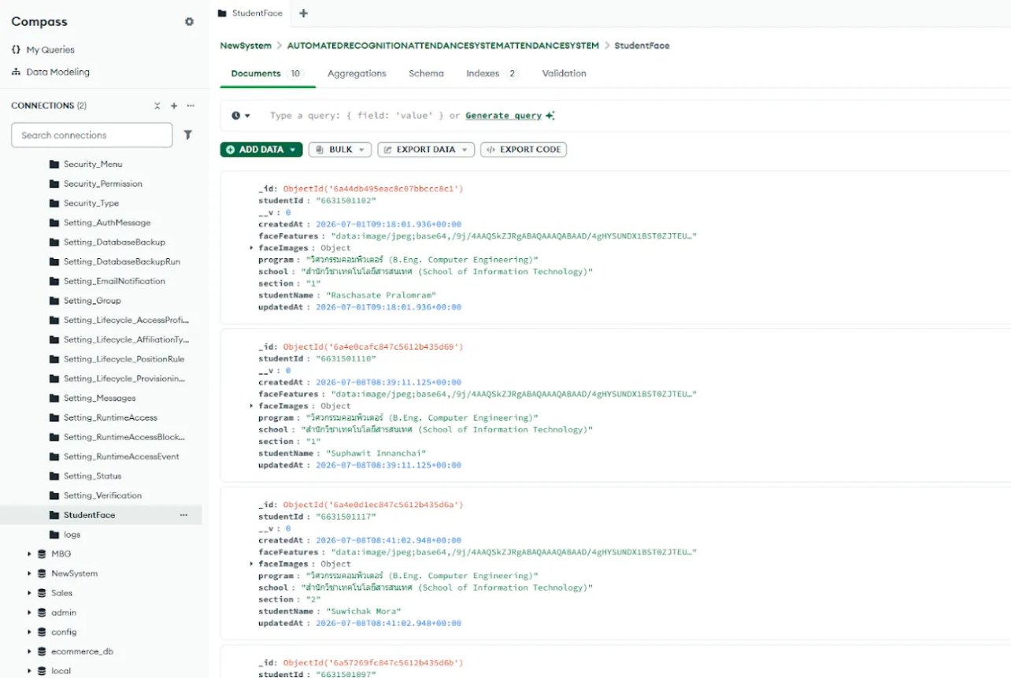

The system utilizes MongoDB as the primary data repository. As illustrated in the StudentFace collection, it securely stores critical student information and biometric data. Each document records identifiers such as the student ID (e.g., 6631501117), full name, and academic details, alongside the faceFeatures field, which securely encodes facial data as a Base64 string. This NoSQL data structure supports highly efficient data retrieval to operate seamlessly with the real-time AI recognition engine.

3.1 High-Level System Flow
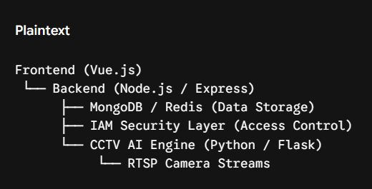

The system operates through a highly structured workflow, beginning with user access via the frontend (Vue.js) and subsequent authentication by the IAM / Security Layer. Requests are then routed to the backend (Node.js / Express). For facial detection, video streams from RTSP cameras are processed by the CCTV AI Engine (Python / Flask), which returns recognition results to the backend. The architecture also utilizes Redis for session and cache management to accelerate dashboard rendering, before permanently storing data in MongoDB.

3.2 System Architecture and Data Flow Description

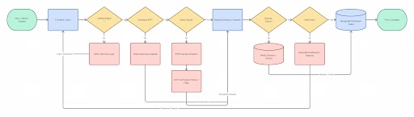

The system operates through a structured workflow that routes user requests, processes AI-based recognition, and manages data persistence. The operational flow is divided into the following key stages:
- User Access and Authentication: The workflow initiates when a user (Admin or Student) interacts with the Frontend (Vue.js). The system first evaluates the authentication status. If the user is unauthenticated, the request is redirected to the IAM / Security Layer to handle login credentials and permission validation before allowing further access.
- Request Routing and Face Capture: Once authenticated, the system determines the nature of the request. If it is not a Standard API request (e.g., manual web-based check-in), the flow activates the Client-side Face Capture module, which forwards the facial input directly to the backend.
- CCTV and AI Integration: For standard API requests, the system checks if it is a Direct Input. If it is not, the flow routes to the automated monitoring pipeline. The RTSP Camera Streams feed video data into the CCTV AI Engine (Python / Flask). The AI engine processes the video for facial recognition and transmits the recognition results to the backend.
- Backend Processing and Caching Strategy: The Backend (Node.js / Express) acts as the central hub, consolidating data from both client-side captures and the AI engine. It then evaluates whether to Bypass Cache. If the cache is utilized, data interacts with Redis (Session / Cache) to rapidly generate dashboards and reports, which are then returned to the frontend interface.
- Data Persistence: If the cache is bypassed, the system checks if the operation is Data Only. Non-data-only requests generate reports for the frontend. Conversely, pure data transactions are committed directly to MongoDB (Persistent Data) for permanent storage, marking the completion of the data flow.
4. Core System Components

4.1 Frontend Modules
Developed in Vue.js, the frontend is compartmentalized into functional UI modules:
- Dashboard: Provides a high-level overview of system status and metrics.
- Registry: Manages student registration workflows and data entry.
- Account Directory: Administers user and student credentials.
- CCTV Viewer: Enables live monitoring and event tracking.
- Security and Settings: Controls access parameters and system-wide configurations.

4.2 Backend Services
The backend bridges end-users, the UI, and AI services. Routes are modularized by function:
- Accounts & Users
- Attendance Processing
- CCTV Integration
- Security & IAM Validation
- System Settings

4.3 CCTV AI Engine
This standalone image-analysis component connects to local camera networks and the backend server. It powers automated attendance workflows and real-time event detection without disrupting core backend operations.

4.4 Security and Access Control (IAM)
The IAM integration guarantees that data and functions are strictly governed by predefined roles. Key security principles include:
- Permission Validation: Enforced prior to granting access to any page or API endpoint.
- Visibility Control: Menus and actionable items are restricted based on permission paths.
- Audit Logging: Comprehensive tracking of all critical system operations.

5. Key Functional Areas

5.1 Registration and Data Management
Automates the onboarding of student data and account provisioning, fully integrated with IAM-based Role-Based Access Control (RBAC).
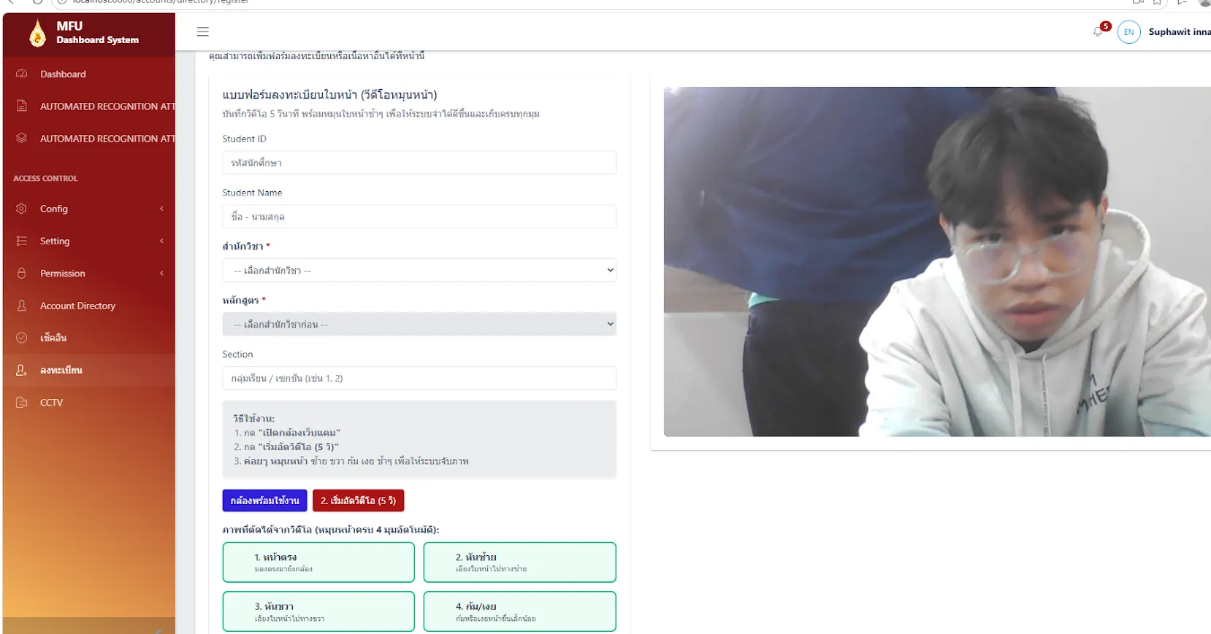

The system automates student data onboarding via a web enrollment form supporting 5-second webcam video capture extracting 4 angles (front, left, right, tilted). Client-side pre-validation uses face-api.js (tinyFaceDetector). Raw images are immediately deleted after embedding extraction to comply with PDPA. The registration form supports bilingual display (TH/EN) for 15 MFU schools while preserving original composite strings in MongoDB. Face embeddings are securely stored in the StudentFace collection and synchronized with the CCTV AI Engine via internal API. Permissions are assigned through the IAM framework.

5.2 AI-Based Attendance
Modernizes the attendance process by blending web application workflows with the AI engine, significantly improving accuracy and eliminating manual verification overhead.
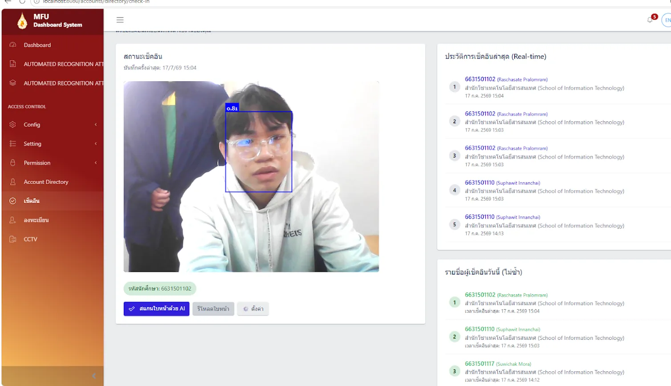

The attendance process is executed through a coordinated workflow between the web application and the AI engine. When a student checks in via webcam, the system uses client-side face-api.js with a Majority Voting mechanism (7-frame buffer, 4 consistent frames required) to stabilize identity detection. The interface displays bounding boxes with confidence scores, records real-time check-in history, and shows unique daily check-ins highlighted in green (text-success). This dual-channel approach (web-based face-api.js and CCTV-based PyTorch engine) effectively eliminates reliance on manual attendance procedures.

5.3 CCTV Monitoring and Tracking
Equips administrators with a dedicated viewer interface to monitor live feeds, review attendance-related events, and oversee operational activities.
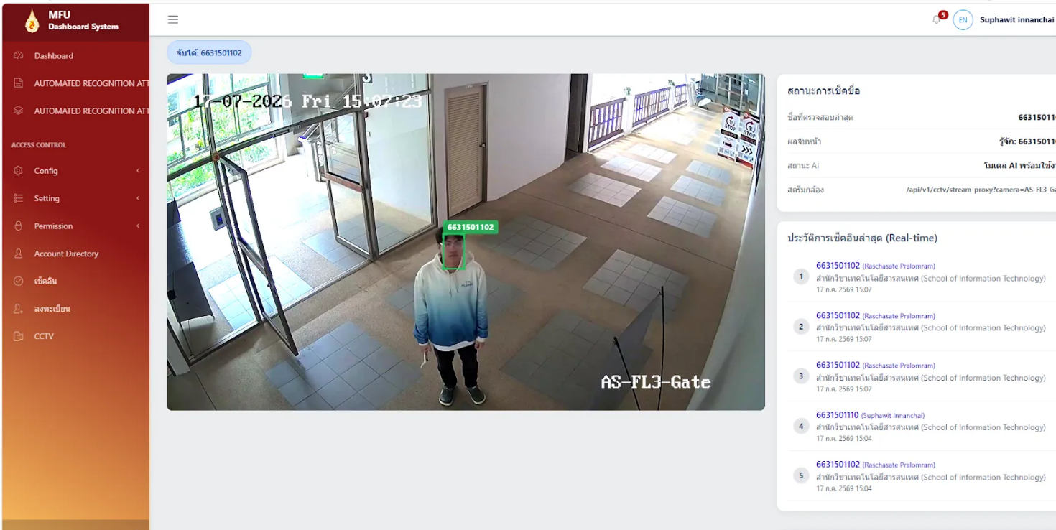

Administrators can access the CCTV Viewer interface to monitor live camera feeds. The system displays streaming footage from RTSP cameras connected directly to the Python AI Engine. It instantly detects faces and identifies individuals (by student ID) on the live stream, significantly enhancing the efficiency of tracking attendance-related events and operational activities.

5.4 Permission Management and Security Review
Features a highly structured permission matrix, including detailed role definitions and group hierarchies, ensuring data access is strictly aligned with user responsibilities.

6. Installation and Deployment

6.1 Prerequisites
The following foundational tools are required for system deployment:
- Docker and Docker Compose
- Git
- A valid environment configuration file (e.g., .env.local)

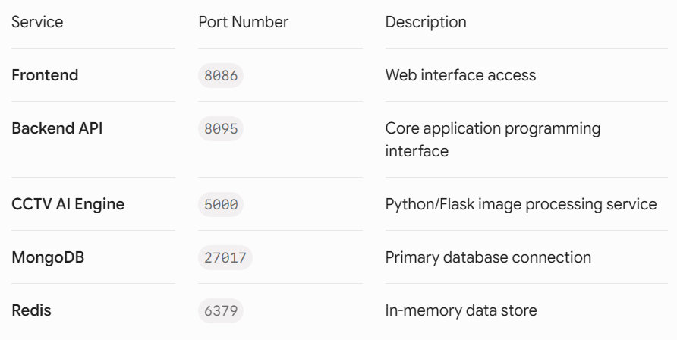
6.2 Required Network Ports
Port | Service / Engine | Host Binding / Purpose
6379 | Redis 7-alpine | 127.0.0.1:6379 (Session and Cache)
27017 | MongoDB 7 | Internal Docker Network (Persistent DB)
8095 | Backend (Node.js/Express) | 127.0.0.1:8095 to 8082 (Core REST API)
5000 | CCTV AI Engine (Python/Flask) | 127.0.0.1:5000 (RTSP and PyTorch Engine)
8086 | Frontend Vue.js (Nginx) | 127.0.0.1:8086 to 80 (Web Dashboard)

6.3 Start-Up Commands
For local deployment and testing, execute the following command:
docker compose --env-file .env.local up -d --build
To safely halt and spin down the system:
docker compose down

6.4 Production Deployment
Production rollout is managed via an isolated deployment workflow, deployed at https://automated-recognition-and-attendance-system.mfu.ac.th, reverse-proxied through Nginx, and automated using GitLab CI/CD pipelines with Harbor container registry.

7. Control Documents and Development Process
A formal document control framework governs the project's lifecycle.
Key Documentation:
- AI-WORKFLOW.md: Governing rules and source-first development principles.
- AI-DOCS-INDEX.md: Master inventory of primary and control documents.
- SYSTEM-MAP.md: Architectural blueprints and API route mapping.
- BOOTSTRAP-CHECKLIST.md: Critical prerequisites prior to initial deployment.
- IAM-UPGRADE.md: Guidelines for IAM compatibility and system upgrades.
- PRD: Product Requirements Document, aligned with current source evidence.
Development Directives:
- Source evidence must be thoroughly reviewed prior to executing implementation changes.
- Rigorous verification and testing must precede any claim of task completion.
- The PRD and change-record logs must be updated concurrently with any feature or behavioral modifications.

8. Summary and Recommendations
The AUTOMATED RECOGNITION and Attendance System exhibits a highly robust foundation across functional delivery, AI integration, and security governance. The convergence of IAM, CCTV monitoring, and automated workflows establishes a scalable architecture capable of modernizing attendance management.

Key Recommendations for Next Steps:
- Documentation Consistency: Continuously synchronize the PRD, source code, and control documents to prevent developmental drift.
- Quality Assurance: Mandate comprehensive unit, integration, and smoke testing protocols prior to any production deployment.
- Operational Runbooks: Establish formal, documented procedures for deployment, version rollbacks, and active operational monitoring.
- Security Audits: Regularly audit database configurations and IAM policies to ensure compliance with current security and privacy regulations.

9. Conclusion
The AUTOMATED RECOGNITION and Attendance System is a comprehensive, enterprise-ready platform addressing user management, AI-driven attendance, CCTV communication, and strict IAM-based access control. Supported by meticulous control documentation and a disciplined development framework, the system is optimally positioned for continued enhancement and immediate deployment in operational environments.

